Contents

**Guru Gobind Singh Jayanti: Celebrating the Tenth Sikh Guru** 1

**Introduction** 1

**Early Life and Spiritual Leadership** 1

**Birth and Childhood** 1

**Becoming the Tenth Guru** 1

**Founding of the Khalsa** 1

**Birth of the Khalsa in 1699** 1

**The Five Ks** 1

**Literary and Martial Contributions** 2

**Warrior and Scholar** 2

**Battle for Justice** 2

**End of Human Guruship and Guru Granth Sahib** 2

**Celebration of Guru Gobind Singh Jayanti** 2

**Observances and Rituals** 2

**Modern Significance** 3

**Conclusion** 3

**References** 3

**Guru Gobind Singh Jayanti: Celebrating the Tenth Sikh Guru**

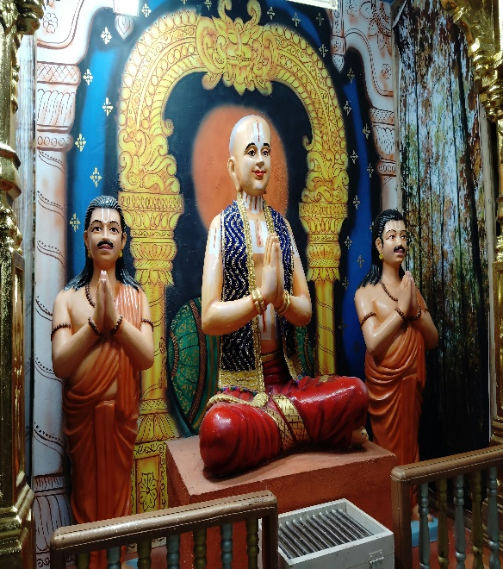**Introduction**

Guru Gobind Singh Jayanti is a revered Sikh festival commemorating the birth anniversary of **Guru Gobind Singh Ji**, the tenth and last human Guru of Sikhism. Born in **1666** in Patna Sahib, Bihar, Guru Gobind Singh Ji played a pivotal role in shaping Sikh identity, militarizing the community, and codifying Sikh spiritual and temporal values.

**Early Life and Spiritual Leadership**

**Birth and Childhood**

Guru Gobind Singh was born on **January 5, 1666** (Gregorian calendar, although the date varies annually as per the Nanakshahi calendar). His original name was **Gobind Rai**, and he was born to **Guru Tegh Bahadur Ji** and **Mata Gujri Ji**. From a young age, he showed remarkable spiritual inclination and leadership qualities.

**Becoming the Tenth Guru**

After the martyrdom of his father, Guru Tegh Bahadur Ji, who sacrificed his life to protect religious freedom, Gobind Rai was declared the **Tenth Guru** at the age of nine in 1675. He took on the immense responsibility of leading the Sikh community during a time of religious and political turmoil.

**Founding of the Khalsa**

**Birth of the Khalsa in 1699**

One of Guru Gobind Singh Ji’s most significant contributions was the founding of the **Khalsa Panth** on **Baisakhi Day in 1699** at Anandpur Sahib. He initiated the first five Sikhs, called the **Panj Pyare (Five Beloved Ones)**, who symbolized devotion, courage, and equality. The Khalsa was established to defend righteousness and oppose tyranny.

**The Five Ks**

Guru Gobind Singh Ji also introduced the **Five Ks (Kakaars)** that Khalsa Sikhs must wear at all times:

* **Kesh** (uncut hair)
* **Kangha** (wooden comb)
* **Kara** (steel bracelet)
* **Kachera** (cotton undergarments)
* **Kirpan** (ceremonial sword)

These symbols signify a Sikh's commitment to faith, discipline, and readiness to stand against injustice.

**Literary and Martial Contributions**

**Warrior and Scholar**

Guru Gobind Singh Ji was not only a warrior but also a prolific writer and poet. He composed significant Sikh scriptures including the **Dasam Granth**, which contains spiritual, philosophical, and martial hymns.

**Battle for Justice**

He led the Sikhs in multiple battles against the Mughal Empire and hill chieftains, asserting the right to religious freedom and justice. Despite personal loss—his four sons and mother died due to Mughal persecution—he remained steadfast in his spiritual mission.

**End of Human Guruship and Guru Granth Sahib**

Before his death in **1708** at Nanded, Maharashtra, Guru Gobind Singh Ji declared that **no more human Gurus** would follow him. He installed the **Guru Granth Sahib**, the Sikh holy scripture, as the **eternal Guru**, establishing the scripture's centrality in Sikh spiritual life.

**Celebration of Guru Gobind Singh Jayanti**

**Observances and Rituals**

Guru Gobind Singh Jayanti is celebrated by Sikhs around the world with deep reverence. The celebrations include:

* **Akhand Path** (continuous reading of Guru Granth Sahib)
* 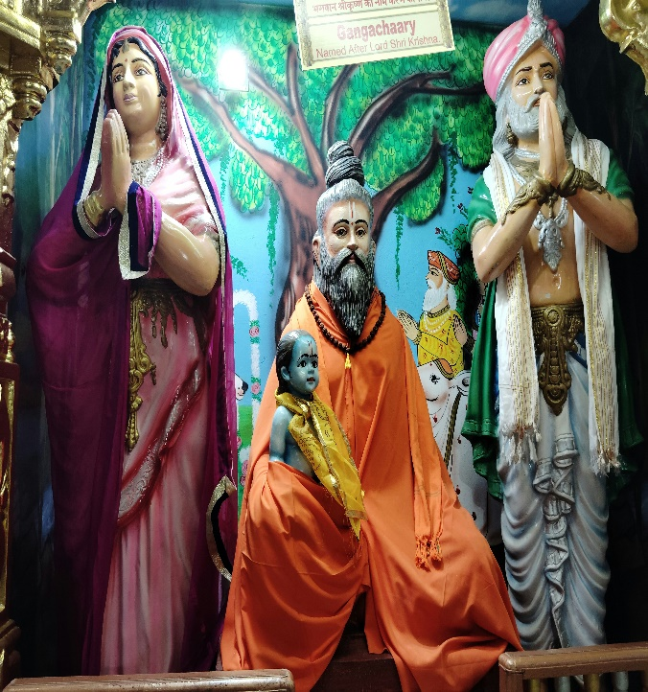**Kirtan and Katha** (spiritual music and discourse)
* **Langar** (community kitchen)
* **Processions (Nagar Kirtans)** showcasing martial arts (Gatka) and Sikh values

**Modern Significance**

The festival serves as a reminder of Guru Gobind Singh Ji’s teachings on **equality, courage, and devotion to truth**. His life continues to inspire millions to stand against injustice and live with dignity and purpose.

**Conclusion**

Guru Gobind Singh Jayanti is not merely a birthday celebration but a reaffirmation of Sikh values and identity. Guru Gobind Singh Ji's life was a beacon of spiritual strength, literary excellence, and warrior courage. His legacy of creating the Khalsa and institutionalizing the Guru Granth Sahib as the eternal Guru continues to shape the Sikh faith and inspire humanity toward righteousness.

**References**

1. Singh, Khushwant. *A History of the Sikhs: Volume 1: 1469–1839*. Oxford University Press, 2004.
2. Dhillon, Dalbir Singh. *Sikhism: Origin and Development*. Atlantic Publishers, 1988.
3. Singh, Patwant. *The Sikhs*. John Murray Publishers, 2000.